SID VALLEY PRACTICE

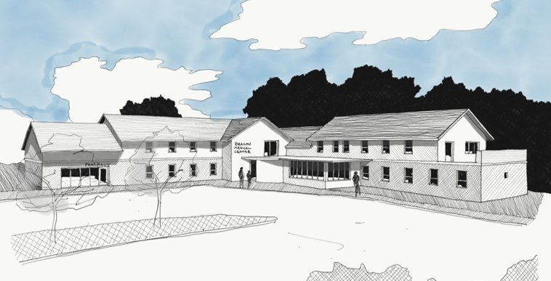

Sidmouth Primary Care Improvement Project

Patient Engagement Summary

Joe Stych

29.3.2022

Contents

|  |  |
| --- | --- |
| Executive Summary …………………….……………….………… | 3 |
| Introduction …………………………………..…………….………… | 4 |
| Why are we doing this project? ……..………………………. | 5 |
| Engagement methodology …………..………………………… | 7 |
| Results …………………………….…………………….………………. | 9 |
| Next Steps …………………………………………………..…………. | 26 |

# Section 1: Executive Summary

This report details the feedback and recommendations following our engagement work which sought the views of patients with regards to moving the branch surgery from Blackmore Health Centre into Sidmouth Victoria Hospital at the same time as extending the Beacon Medical Centre.

Blackmore Health Centre is no longer fit for purpose and not well suited for modern healthcare facilities. The 2015 Care Quality Commission report concluded: ‘The practice building itself was old and not fit for purpose. However, the practice was opening a new medical centre which would deliver most patient services, reducing the load on the current health centre building.

The adjacent Sidmouth Victoria Hospital has vacant space which could accommodate current clinical work being undertaken at Blackmore Health Centre. This should have minimal impact on patients. Sid Valley Practice is providing comprehensive primary care services to patients from the Beacon Medical Centre. We are working with local practices in Primary Care Networks to provide additional services and need the additional space to do this.

We need to be able to provide a sustainable service that safeguards provision of primary care services in the Sid Valley for future generations to come. We have recently changed our practice boundary to take on patients from Newton Poppleford and geographically these patients are best served by increasing capacity at the Beacon.

We recently conducted a patient and stakeholder engagement to seek the views of patients regarding the proposed changes. We also wanted to determine any adverse events that may arise because of the changes. Our plans have considered patient feedback and been amended to reflect this.

Following completion of the patient and stakeholder engagement and a review of the feedback received Sid Valley Practice are proposing that the project moves forward.

# Section 2: Introduction

All patients are registered at the Beacon Medical Centre and can be seen at either Blackmore Health Centre or the Beacon Medical Centre. Our current patient list size is 14600. We have a growing patient list having recently changed our practice boundary to accommodate patients from Newton Poppleford. We are a training practice, and we teach, support, and supervise GP Registrars, GP trainees, medical students, and student nurses. We are members of HOSMS Primary Care Network, along with Honiton Surgery and Ottery St Mary. As a Primary Care Network, we have been able to recruit other healthcare workers based in Sidmouth such as physios, pharmacists, mental health workers and an occupation therapist to help us deliver primary care.

The national Government strategy continues to be funding Primary Care Networks to enable employment of additional rules. These teams expect to work in a multi-disciplinary environment within a larger health centre setting. Locally we have a more diverse and highly skilled workforce who require facilities more in line with a large multi-functional site. As well as their own lists GPs will often be training students and overseeing nurses with additional roles or other members of the team.

The direction of travel for Primary Care is integration with Secondary Care. The Royal Devon and Exeter NHS Trust run Sidmouth Victoria Hospital and this unique opportunity to co-locate primary and secondary care in the hospital in the Sid Valley will bring numerous health benefits to the local community. Reduced admissions, improved preventative care, earlier discharges from hospital settings and timely senior support to inpatients in the hospital are all achievable with moving the branch.

Blackmore Health Centre was classified as not for fit purpose by our regulators the Care Quality Commission back in 2015. Despite several failed attempts we have failed to find a workable solution for this site since. As part of a bid for funding in 2015 an options appraisal was undertaken. From this the favoured option to allow us to provide sustainable primary care service was to move the branch surgery into Sidmouth Victoria Hospital and extend the Beacon Medical Centre.

# Section 3: Why are we doing this project?

**Benefits of moving into the hospital**

* Provides an integrated care model where there is joined up working between primary and secondary care.
* Better care of patient on hospital wards. GPs will be on site to review patients who deteriorate on the ward. It has been identified that many patients from the Medical Ward in Sidmouth get escalated up to Exeter putting demand on the ambulance service and Royal Devon & Exeter acute hospital. This can result in an unnecessary trip for unwell patients.
* Reduced demand on ambulance service from hospital will mean faster response times to patients locally for other emergencies.
* GPs will be able to assist more closely with planning discharge so the hospital can get patients home more efficiently.
* Patients from the local area will benefit from easier access to their local hospital.
* End of life care improvements with GPs on the ground to be able to admit deteriorating patients into Sidmouth Hospital.
* Greater pastoral support for junior doctors on hospital ward.
* Colocation with Urgent Care Response Team for co-ordinated approach for keeping patient safe at home in their own environment not in acute hospital setting.
* Improved communication with Dementia Matrons to help safeguard dementia patients.
* Improved communication with Community Nursing Team.
* Colocation with social care to address needs of vulnerable adults.
* Sits members of the Complex Care Team under the same roof so we can address needs of at-risk patients more efficiently.
* GPs working alongside Hospital consultants - educational benefits. Better follow up arrangements.
* Reduced demand on acute hospital services. Less Sidmouth patients ending up in hospital in Exeter on an acute ward or in Accident & Emergency.
* Improves parking as retains current joint library car park and hospital parking.
* Making the hospital more efficient in terms of use and cost makes its future more secure.
* A GP presence in the hospital will ensure the hospital is retained long term even if there are bed closures or units closures within it.
* This creates a Sidmouth Hub which is in line with NHS/Government working.

**Benefits for extending the Beacon Medical Centre**

* Increasing service productivity - working across 2 larger sites is highly inefficient.
* Facility created to offer larger group consultations room to allow better health promotion and early intervention.
* Another surgical suite so patients can have operations performed locally rather than be referred up to Exeter for surgery
* Room for Learning Disability reviews
* More room for improving mental health services. Room for counselling services. Additional rooms to accommodate Primary Care Additional workforce which will include Pharmacists / Physios / Pharmacy technicians / Mental Health workers/Care Home support staff.
* 2 large sites create unnecessary expense that the NHS must fund in terms of kit/drugs/stock/staff costs - we need to protect the NHS.
* Space is needed to accommodate the Newton Poppleford patients from a recent boundary change. This could see 2000 new patients register at the practice.

**Why not a larger facility in the hospital?**

* The Royal Devon & Exeter NHS Trust have reviewed use of the Sidmouth Victoria Hospital site and there is no space.
* With changed working patterns we need fewer face to face appointments across the board.
* Blackmore used to run 2 clinics of warfarin blood tests daily - new drugs have replaced warfarin and there has been a move to switch patients to new anticoagulants so these appointments are no longer needed.
* Nurses are running remote video and telephone consultations for chronic disease reviews. We have limited equipment for this, and this can more efficiently be managed from the main surgery on Beacon site. We need less face-to-face appointments for chronic disease monitoring with new technologies that have been embraced.

# Section 4: Engagement Methodology

Over the last two years we have engaged with our patients and stakeholders to obtain feedback on the impact of the proposed changes and to understand whether the best interests of the patients using the surgery would be served by the proposed changes.

Suggested service changes were formally presented to our Patient Participation Group on 14.7.20. Feedback on a draft survey was sought at this time. With support from Devon Clinical Commissioning Group Communications team a survey and formal engagement process was launched. We also put a printed leaflet together and set up information boards to go outside both surgeries and information was posted on the surgery website.

We personally invited all patients to take part in the survey by using text and email where we had consent. We wrote to neighbouring residents to Blackmore, Sidmouth Victoria Hospital, and the Beacon Medical Centre to inform them of proposed changes and to invite them to partake in the survey. We also made the survey available online on our web site. Paper copies were available outside both surgery sites with information boards informing on plans. We also wrote to our MP, Sidmouth Town Council, East Devon District Council, and local Councillors. Neighbouring practices and our Primary Care Network colleagues were briefed by the practice manager. The leaflet was also displayed in local pharmacies, Sidmouth Hospital and Sidmouth Library. A dedicated webpage was set up on the surgery website providing information and links to an online Google Forms survey together with an e mail address for comments. A media statement was published and covered by the Sidmouth Herald, Devon Live and Sidmouth Nub News. Devon Clinical Commissioning Group Communications Team sent an information pack to statutory bodies.

The patient and stakeholder communication launched on 20.7.20 for an initial period of 2 weeks. However, this was then extended to seek wider feedback and the information gathering left open. Survey results were analysed and comments from letters and e mails responded to and collated. Following on from this initial work the practice appointed Healthwatch to undertake further engagement work to explore the views of harder to reach patients. Throughout this period the practice has continued to meet 6 weekly with the Patient Participation Group and had the development update as a regular standing item to keep the group informed on progress.

Following on from the initial engagement work and then the Healthwatch survey further meetings have been held between the practice, Patient Participation Group, Sustainability and Transformation Lead and Clinical Commissioning Group to explore and mitigate against raised concerns. Following these surveys 3 focus groups were formed with the Patient Participation Group and they went ahead and met with the practice to further analyse received feedback. Plans were made to mitigate against any adverse effects the proposed changes may have on patients. At the same time, it was recognised that not everything all patients want would be achievable. One group reviewed information coming back from the patient surveys, letters and email feedback and helped us collate feedback through our web site to keep patients informed. One explored the parking and transport challenges and worked on mitigating raised concerns. Helpfully one looked at future provision of services from Sidmouth Hospital and worked with us and the Royal Devon & Exeter Hospital NHS Trust to increase the number of rooms available to us in the hospital to ensure there would be adequate centre of town service provision.

Leading on from this the Patient Participation Group formally voted in favour of supporting the project and helping the practice move things forwards. A letter of support from the chair is attached at Appendix 9.

# Section 5: Results

The engagement work was a hugely worthwhile exercise enabling the team working on this scheme to receive the thoughts of the local stakeholders who were engaged with as part of this process. The feedback received was constructive, and where any detailed issues have been raised that directly relate to the scheme it is considered that these have been addressed or responded to. Eighty-three individual comments were received by e mail or letter. The issues identified are tabulated, together with responses to the points raised.

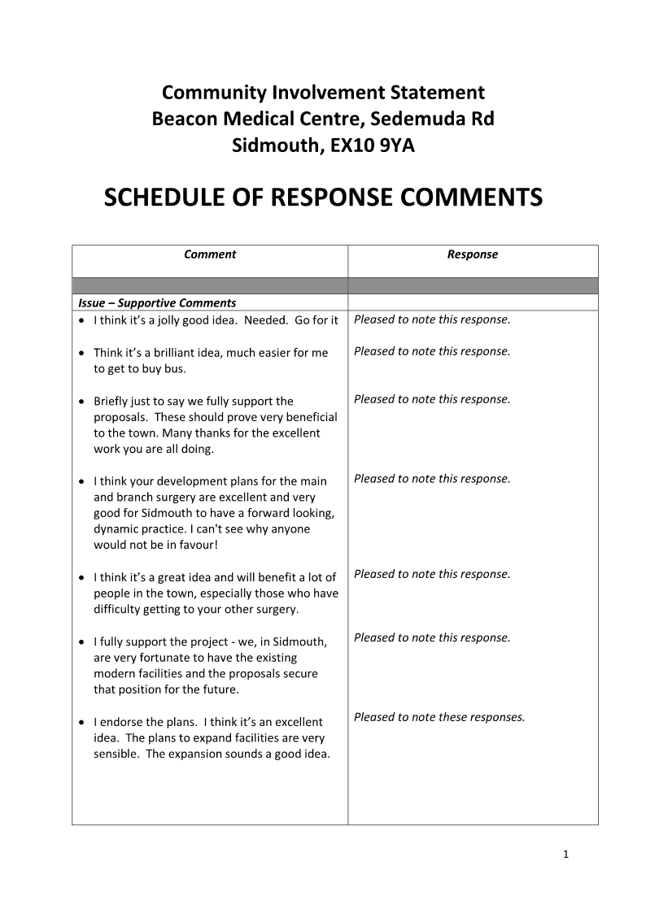

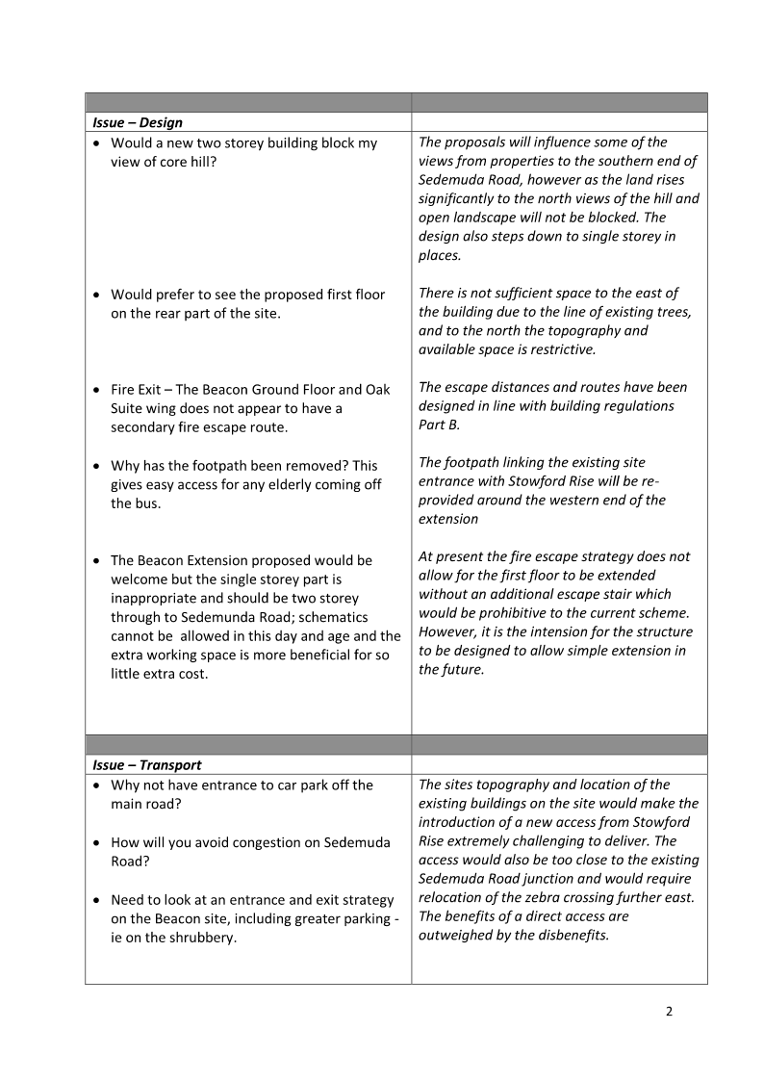

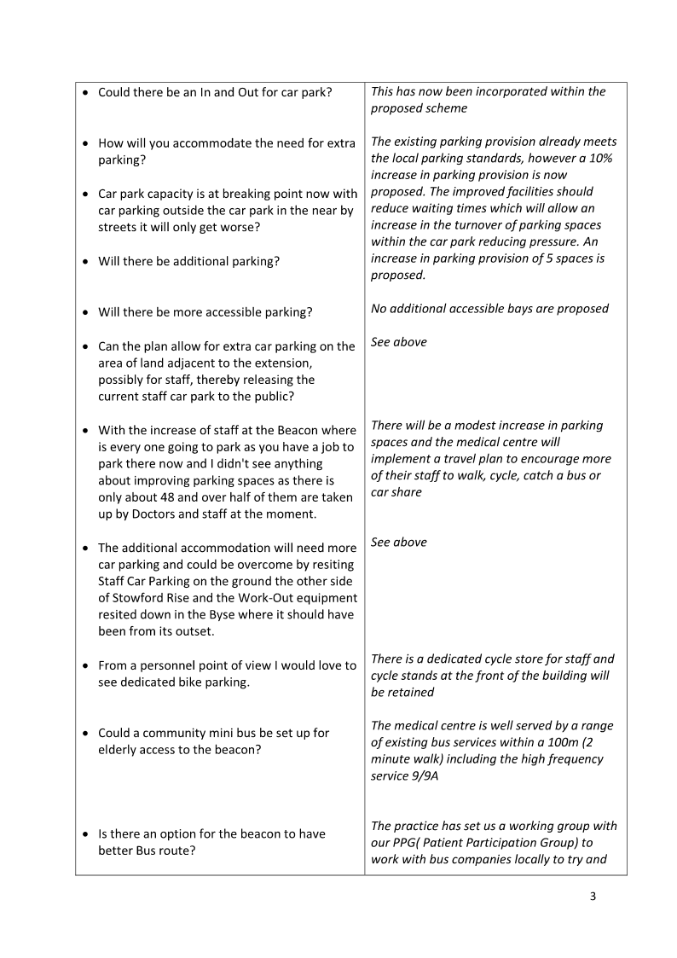

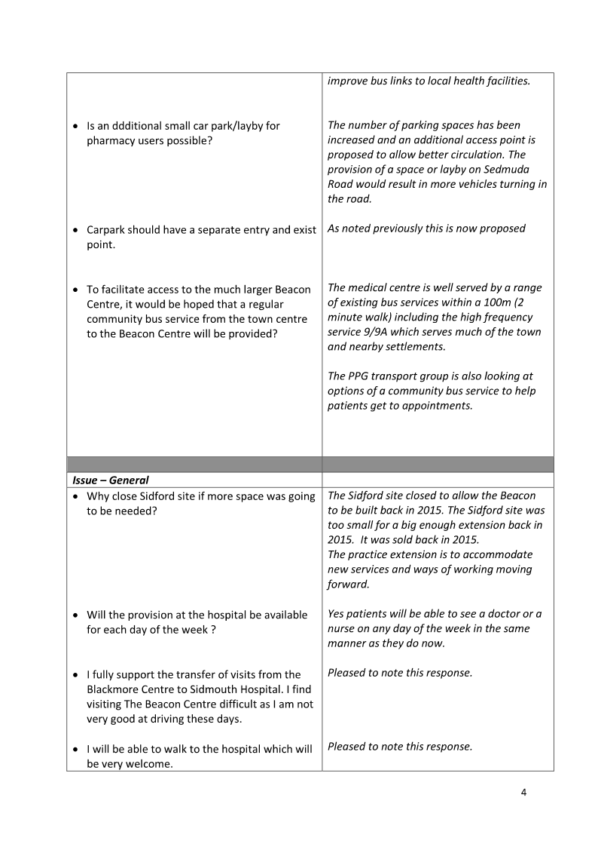



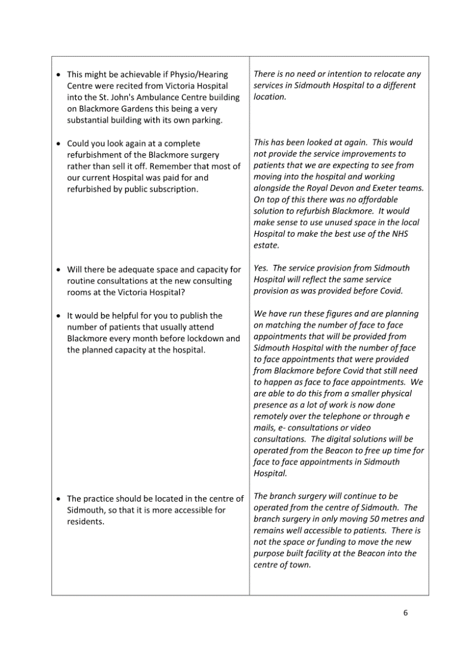

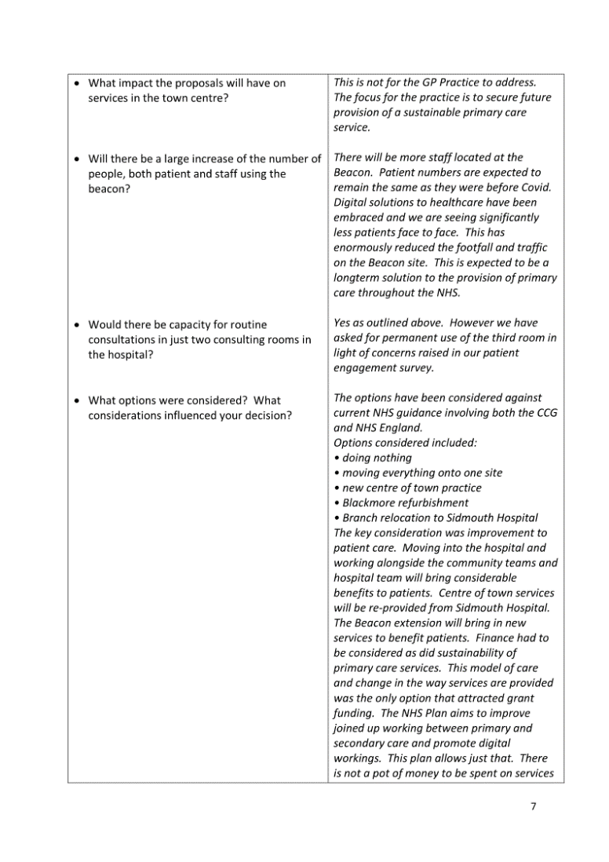

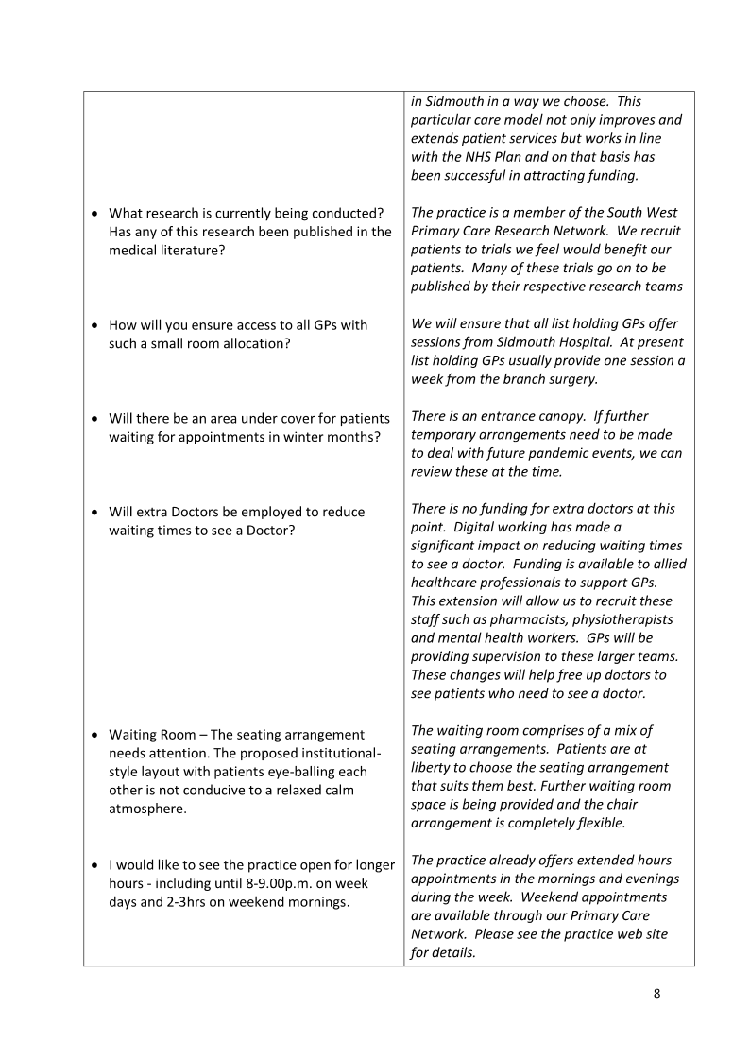

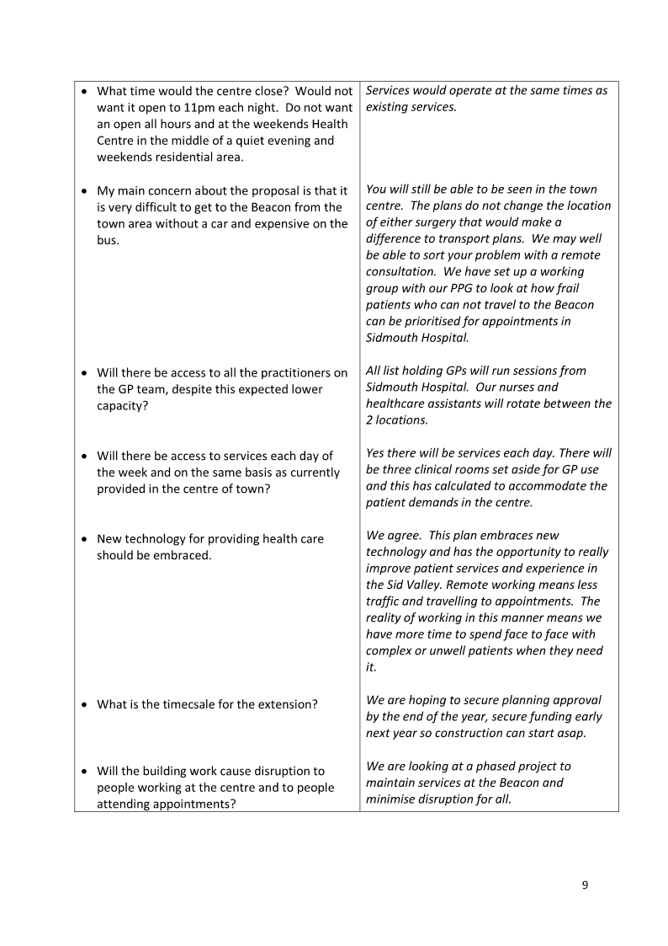

On top of this a total of 1108 surveys were returned. This represents 7.4 % of the list size at the time the survey ran.

Broadly speaking there is almost an identical split of patients who prefer to visit the Beacon and Blackmore. More people walk to the Blackmore Health centre whereas more people tend to drive or use public transport to access the Beacon.

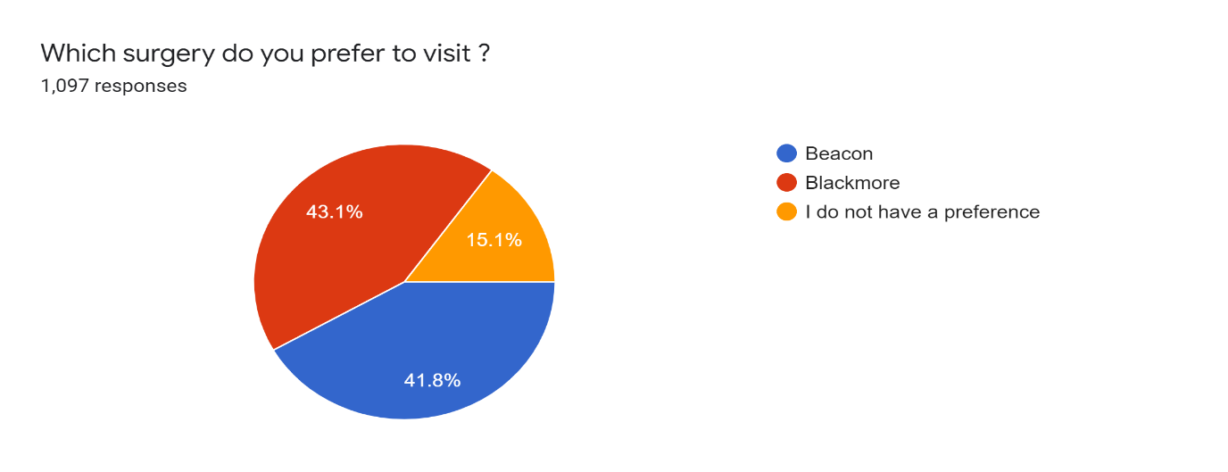

There was a strong feeling that a centre of town service continues.

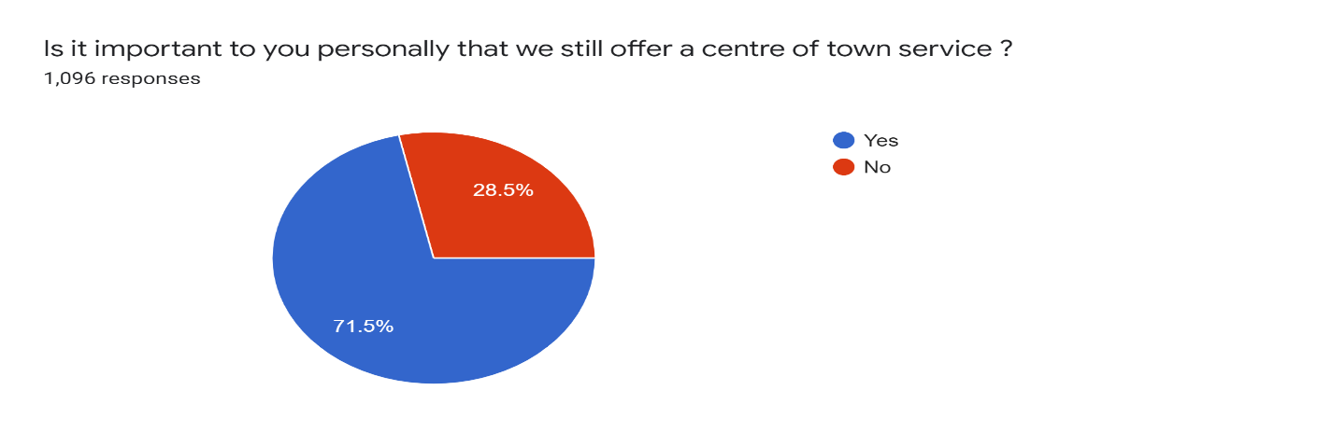

Many practice patients are already familiar with the Sidmouth Victoria Hospital with 34.5% already accessing it to use services. In fact, 69.8% of patients had no concerns about the suggested move to Sidmouth Victoria Hospital and thought this would be beneficial to patients.

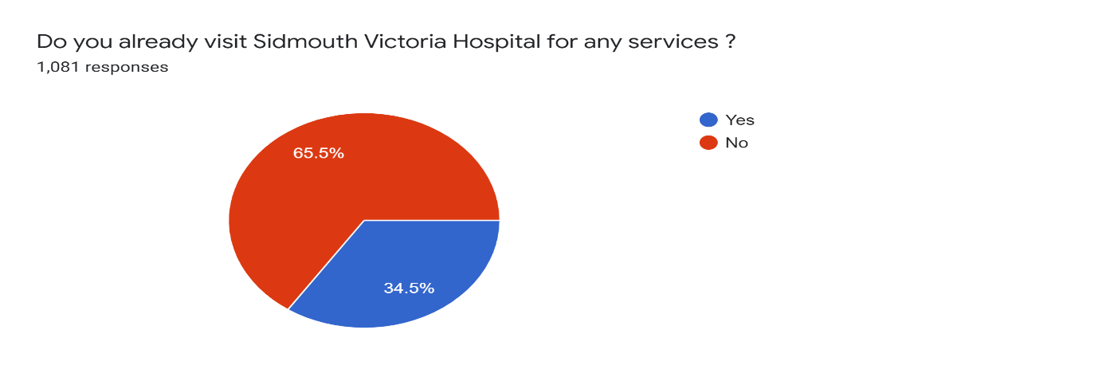

Most patients 56.5% thought that the Beacon extension would be beneficial to patients.

More patients walk to Blackmore 58.3% than they do to the Beacon 13.9%. More patients get to the Beacon by car 71.2% than get to Blackmore by car 33.6%. This is likely to see changes to local traffic patterns.

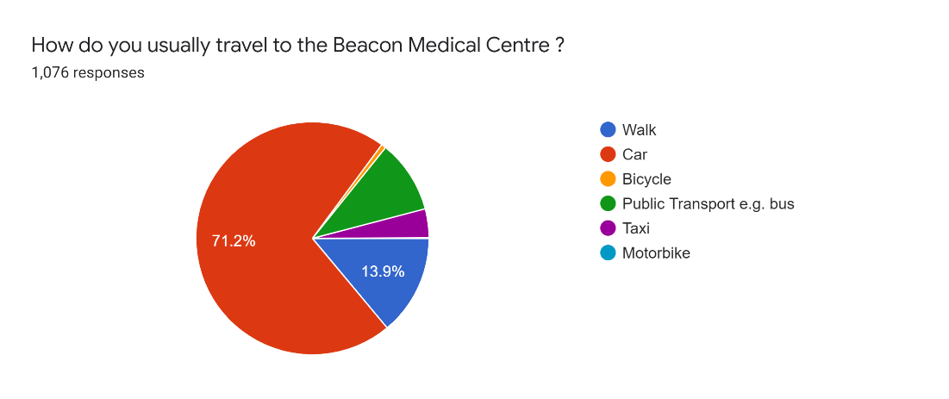

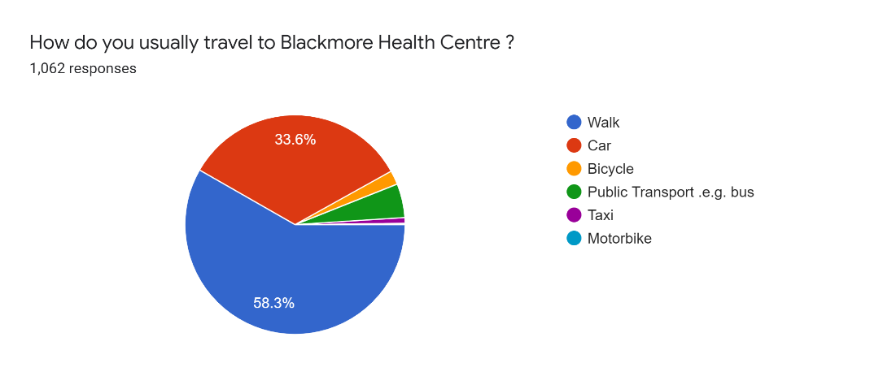

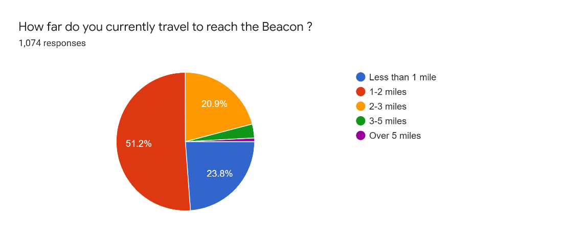

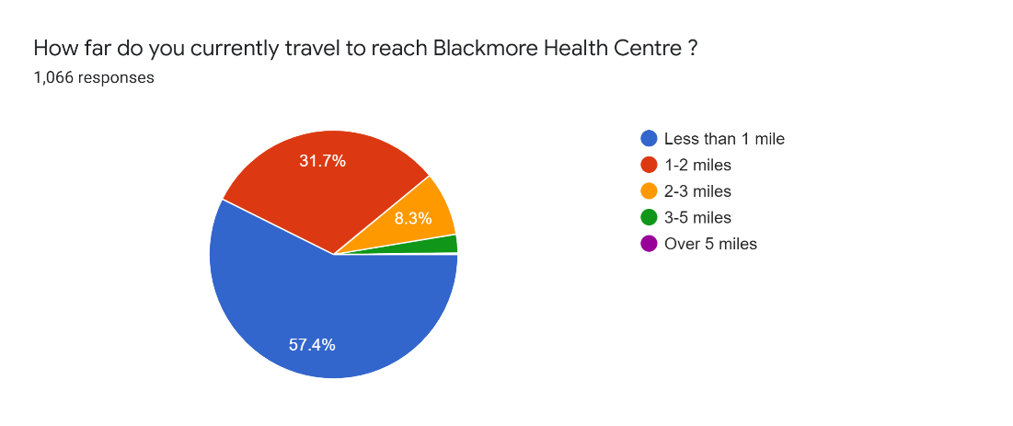

There were concerns about parking on both sites. With 30.3% of respondents concerned about the Beacon and 19.8% concerned about Blackmore parking.

People were less concerned about getting to Blackmore than the Beacon with only 1.8% of patients having concerns about accessing Sidmouth Hospital, while 20.1% of patients had concerns about accessing the Beacon.

Sid Valley patients are frequent service users presenting regularly for multiple episodes of care during a year.

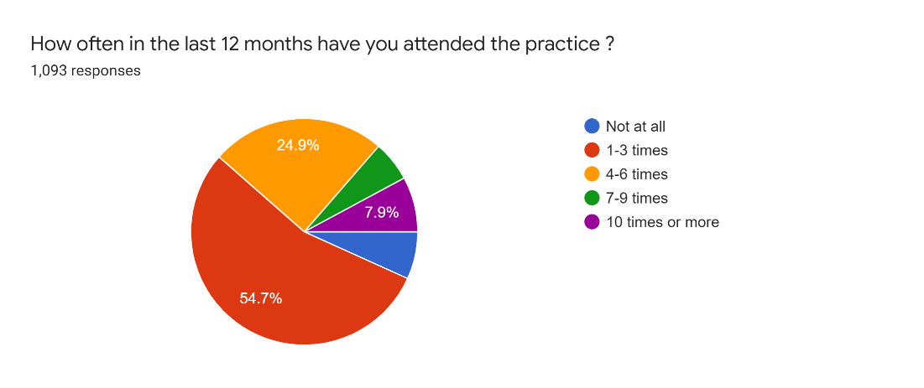

The initial survey was criticised for not recording patient demographics to break down the data to assess the impact on more vulnerable groups. There were also concerns that some less technologically capable patients may have been disadvantaged. The practice commissioned Healthwatch to undertake further engagement work to help identify these patients and seek their opinions. Appendix 2.

The Healthwatch survey ran for 6 weeks and followed on from our original survey. This details 131 respondents. Similar themes emerged from this as our original survey. There was a feeling that the response rate was low as the previous survey had captured opinion already. Healthwatch commented that response rates can be lower when there is not a strong sense of objection towards a plan. They also noticed a sense of survey fatigue as patients were already aware of this scheme. This scheme has been covered several times in the local press since the first funding bid for STP Wave 4 Capital back in 2018.

***Findings of the three focus groups:***

**Parking/Travel**

|  |  |
| --- | --- |
| Patient Feedback | How have we responded? |
| Difficult one-way car park at Beacon | Amended car park to form one way system with an in and an out  Parking restrictions from council from main road up to surgery entrance to help residents and traffic flow on site |
| Insufficient parking at Beacon | Added 3 more parking spaces  Remote working has significantly reduced traffic flow on site  Increase to staff working from home  A plan to stagger clinic times and face to face appointment slots could further reduce traffic flow significantly if parking is an issue which it has not been since more remote working has been adopted |
| Difficult parking at Sidmouth Hospital | Retained the GP patient car park and plan in place to fit barrier to prevent shoppers parking |
| Bus routes difficult for patients | Newton Poppleford patients have been pleased with bus and road access to the Beacon  Dartline, Stagecoach and council contacted about proposed changes. There are no current plans to change bus services  Sidmouth Hospice increasing numbers of volunteers who can help their clients attend surgery appointment  Sidmouth Voluntary Services can bring patients to appointments  Remote working offers some solutions here |

**Centre of town service provision**

PPG members helped to look at patients' feedback on the planned service provision at Sidmouth Victoria Hospital. The original plan had been for 2 permanent rooms in Sidmouth Victoria Hospital with ad hoc use of other rooms. It was felt that with a third room we would ensure that sufficient appointments could be provided on the Hospital site. Plans have been amended so the practice have exclusive use of 3 rooms. Other rooms can be booked on top of this on an ad hoc basis.

**Potential appointment provision in centre of town**

*Table looking at numbers of appointments with different scenarios:*

|  |  |  |  |  |  |  |
| --- | --- | --- | --- | --- | --- | --- |
|  | Monday | Tuesday | Wednesday | Thursday | Friday | Total |
| GP pre-Covid | 39 | 16 | 24 | 37 | 28 | 144 |
| GP 2 rooms in hospital 9 sessions | 28 | 16 | 28 | 28 | 28 | 128 |
| GP 2 rooms in hospital 10 sessions | 28 | 28 | 28 | 28 | 28 | 140 |
| Nurse pre-Covid | 77 | 61 | 82 | 64 | 73 | 357 |
| Nurse 2 rooms in hospital 9 sessions | 30 | 15 | 30 | 30 | 30 | 135 |
| Nurse 2 rooms in hospital 10 sessions | 30 | 30 | 30 | 30 | 30 | 150 |
| Nurse 3 rooms in hospital 9 sessions | 60 | 30 | 60 | 60 | 60 | 270 |
| Nurse 3 rooms in hospital 10 sessions | 60 | 60 | 60 | 60 | 60 | 300 |
| Nurse pre-Covid equivalent with appointments no longer needed due to INR reduction and remote reviews | 51 | 35 | 56 | 38 | 47 | 227 |

The above table looks at planned changes to face to face appointment numbers in the centre of town with move from Blackmore Health Centre to Sidmouth Hospital. Currently 26.1% of appointments occur at Blackmore and 73.9% of activity at Beacon. This scheme would not be taking services from the centre of town and re-providing these from the Beacon site. It aims to move services from Blackmore into Sidmouth Hospital. The extra capacity at the Beacon site would be bringing new services into Sidmouth and providing for the Newton Poppleford population.

The pre-Covid appointments look at an average number of daily appointments in October and November 2019. This was at a time when few people are away on holiday and before Covid was an issue.

The table above shows how many face-to-face appointments would be provided with the potential scenarios available with a move across to Sidmouth Hospital. We have modelled the numbers of appointments that would be available if we provide 9 and 10 sessions of time from either 2 or 3 rooms. Currently Blackmore Health Centre is closed on a Tuesday afternoon which represents 9 sessions a week of clinical time. In the table above nurse appointments combines nurse and health care assistant appointments. There is no plan to change the proportion of these appointments.

Post Covid we have seen huge changes in the way appointments are provided. GPs are estimating that as much as 50% of their work can be managed remotely. We have identified 11 chronic disease appointments a day at Blackmore that our nurses were undertaking that are now done remotely and will remain as remotely provided appointments moving forward. Blood tests for anticoagulants have reduced with patients being switched to new drugs. We have reduced patients coming for regular anticoagulant monitoring blood tests from 523 to 168 –a 67.7% reduction in number of nurse appointments. This represents 15 nurse bloods test appointments a day at Blackmore that no longer need to be provided. Again, this is a permanent change.

A plan to provide one GP for an equivalent 9 sessions in Sidmouth hospital would provide 128 appointments. So, in this scenario, GP face to face appointments would drop from 144 to 128. Increasing the town centre GP to 10 sessions of availability would increase appointments to 140. Considering GPs are expecting to be able to manage 50% of their workload remotely patient access should improve. In a post Covid world reducing GP face to face appointment need by 50% would need 72 face to face appointments to provide the same service as patients received before Covid. We are planning for this to remain around 140.

Looking at nurse numbers needs more thought. If we look at all the nurse appointments that still need to be provided in a post Covid world, if we are to provide the same service as we were before Covid, we will need to provide 227 appointments each week. If we have one room for a nurse/HCA in Sidmouth hospital this would provide 135 appointments over 9 sessions or 150 over 10 sessions each week. If we have 2 nurse/HCA rooms, we could provide up 270 appointments over 9 sessions or 300 over 10 sessions each week. If we have shared use of the third room for 5 sessions a week, we could provide 225 appointments each week.

With these figures in mind the group agreed that we could maintain current services with a move into Sidmouth Hospital with exclusive use of 1 GP and 2 Nurse/HCA rooms on a permanent basis. We have worked with the Royal Devon & Exeter NHS Trust and NHS Property Services to ensure we will have these 3 rooms for our exclusive use to allow this.

So, service provision would remain stable. Patient parking options would improve. Access to the surgery for disability access would improve as patients can be dropped off directly outside the Hospital. In summary we feel this would benefit patients.

# Section 6: Next Steps

We will submit our findings to Devon CCG with an application to move the branch surgery into Sidmouth Hospital and extend the Beacon Medical Centre.

We would like to thank everyone who took part in this engagement.