Hormone Replacement Therapy (HRT) Review Questionnaire

Questions:
1. Do you know the name of the hormone replacement therapy (HRT) that you want?
- Yes
- No
- No, but I'd like the same one I was given last time
2. What is the name of your HRT?

3. Have you started taking any new regular medications or health supplements recently?
(Please include any over-the-counter supplements or medications)
- Yes
- No
4. Which new medications or health supplements have you started taking since your last prescription?

5. Have you been diagnosed with any new health conditions since we last issued your HRT?
(These could be any conditions but in particular: any breast or ovarian conditions, blood clots or a clotting disorder, cancer, heart disease, liver disease, migraines or diabetes)
- Yes
- No
6. What new health conditions have you been diagnosed with since your last HRT issue?

7. Is HRT helping your symptoms?
- Yes
- No
8. How long have you been taking HRT?
- Enter text
9. Are you having any side effects or problems from your HRT?
- Yes
- No
10. Please describe any side effects or problems here

11. Do you have any vaginal dryness or discomfort?
- Yes
- No
12. Are you up to date with your breast screening (mammogram)?
(A mammogram is a type of X-ray that looks for breast cancer. You should be invited to have a mammogram every 3 years between the ages of 50 and 71 unless you have been told otherwise by a healthcare professional.)
- Yes
- No
- I'm not sure
13. Are you up to date with your cervical screening (smear test)?
(Unless you have been told otherwise by a healthcare professional, you should be invited to have a smear test every 3 years between the ages of 25 and 49, every 5 years from age 50 to 64 and then over 65 if one of your last 3 smear tests was abnormal.)
- Yes
- No
- I'm not sure
14. Do you have a family history of breast cancer?
- Yes
- No
15. Have you had any new or unexpected vaginal bleeding/spotting?
(Such as after sex, between periods or after 12 months of not having a period)
- Yes
- No
16. Have you had a hysterectomy?
(A hysterectomy is where you’ve had surgery to remove your womb [uterus].)
- Yes
- No
17. Are you currently using contraception?
(Please note, HRT does not act as contraception)
- Yes
- No
18. Which method of contraception do you use?

19. Do you require advice about contraception?
- Yes
- No
20. What is your smoking status?
- Current Smoker
- Ex-smoker
- Never Smoked
21. How much do you smoke? or How much did you smoke?
- <1 cigarette or equivalent per day
- 1-9 cigarettes or equivalent per day
- 10-19 cigarettes or equivalent per day
- 20-39 cigarettes or equivalent per day
- 40+ cigarettes or equivalent per day
22. How many years did you smoke for?

23. Are you able to provide a blood pressure reading?
(As part of the review of your HRT we need an up-to-date blood pressure reading)
- Yes
- No
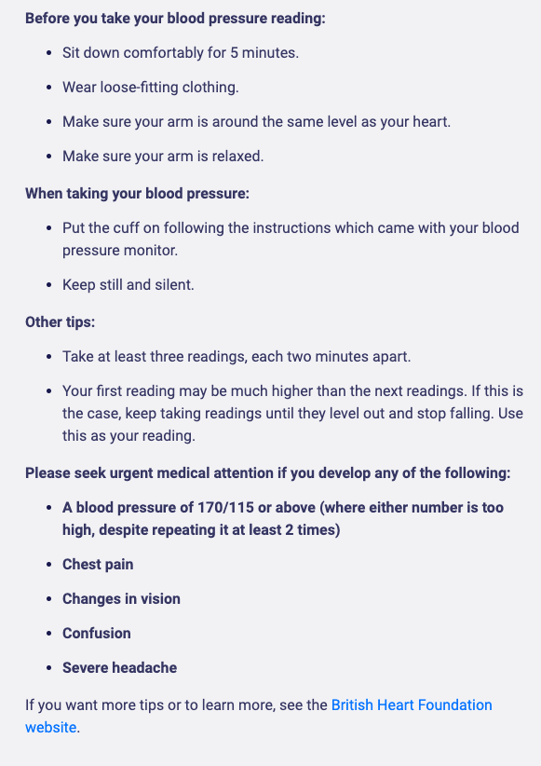
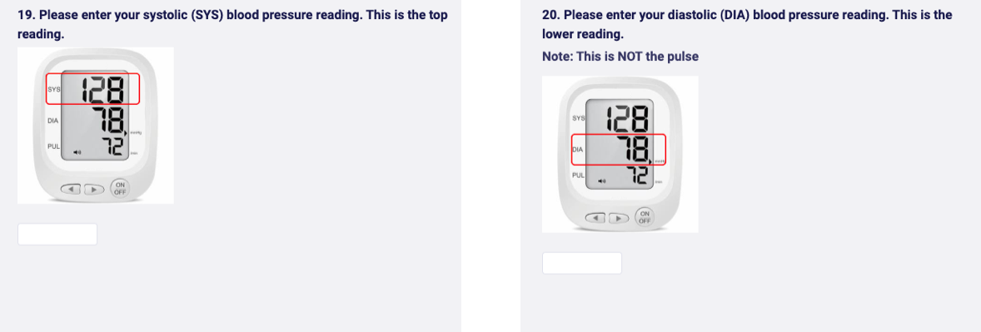
24. Are you able to provide a weight and height reading?
- Yes, both
- Weight Only
- Height Only
- No
25. Please enter your weight in kilograms.

26. Please enter your height in metres.

27. Are you considering stopping your HRT?
- Yes
- No
28. Is there anything else regarding your HRT that you would like to change or discuss?

